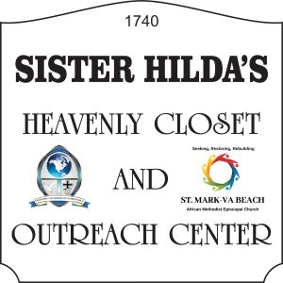
Church – (757) 428-7310
Patricia Hood, Director
Cheryl Shannon, President APL Missionary Society

FREE
CLOTHES, FOOD and School Supplies; Health Literature
(Women, Men, Children and Baby Clothes; Non-perishable Food)
SATURDAY
1740 Potters Road, Virginia Beach

!! ULTIMATE SPRITUAL EXPERIENCE !!
Join Us
St. Mark AME Church VA Beach Page and Tony D, Boone Page
Dial-In Conference Line: 515-604-9314 Access Code 971854#
Sunday Worship Service – 10:00 am Bible Study – Wednesday @ 7:00pm
Website – stmarkamevabeach.com
Reverend Tony D. Boone, Pastor
Reverend Melodie P. Boone, Assistant Pastor

